**Exploratory Data Analysis of Zomato Restaurant**

The **aim** of the project "Exploratory Data Analysis of Zomato Restaurant " is to gain insights into the characteristics of restaurants listed on Zomato, understand key patterns and trends, and provide valuable information for users, restaurant owners, and Zomato itself. The analysis will encompass various aspects of the dataset, including geographical distribution, popular cuisines, pricing, ratings.

Steps to be taken in the project:

Step-1: Importing all the necessary libraries like pandas, numpy, matplotlib, seaborn

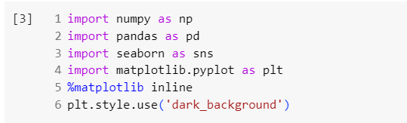

Step-2: Loading the csv-dataset

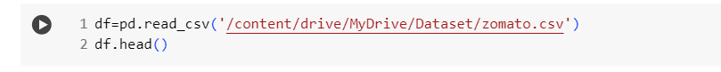

Step-3: Dropping unnecessary columns by using drop function



Step-4: Using info function to gather information like data type, null value in the dataset

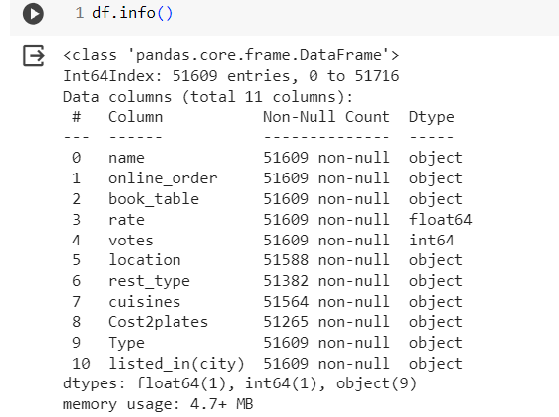

Step-4: Now next step is to drop duplicates

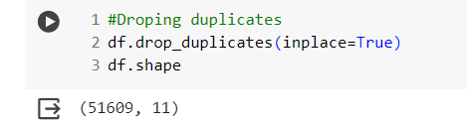

Step-5: Cleaning the rate column, i.e. removing New, nan, /,- from the column by using handlerate function

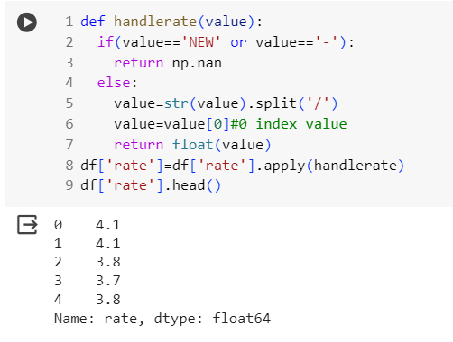

Step-6: Filling null values in rate column with mean

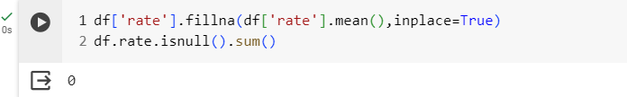

Step-7: Renaming columns

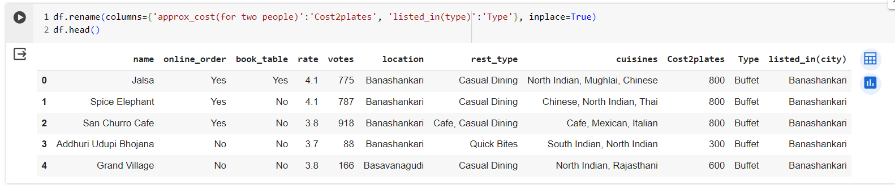

Step-7: Cleaning Cost2plates columns, i.e., removing commas from the values by using handlecomma function

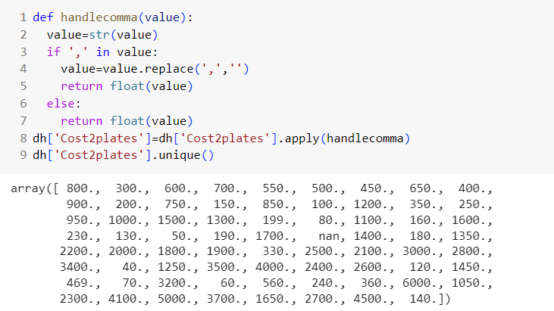

Step-8: Cleaning Rest type column by making clusters of less number restaurants type

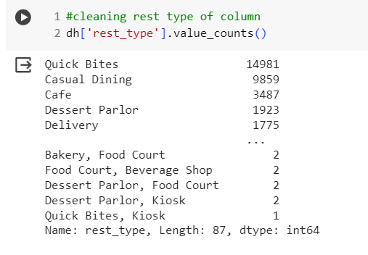

**Now we will make list of restaurants with the value less than 1000**

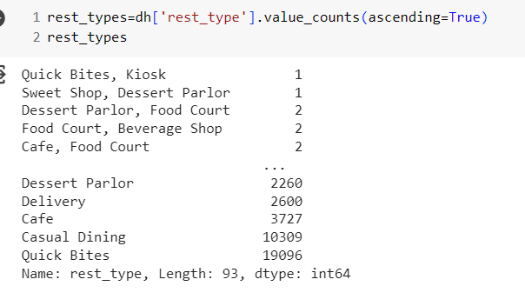

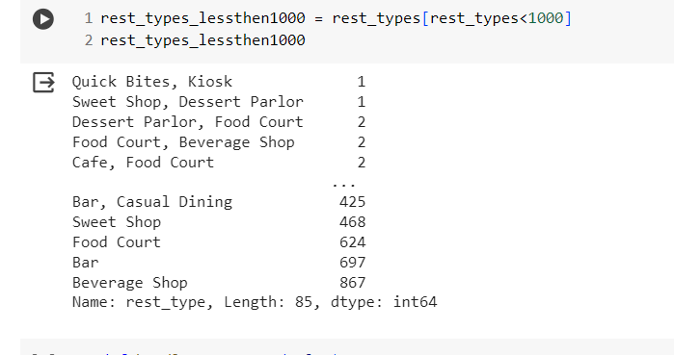

**Making Rest types less than 1000 in frequency as others**

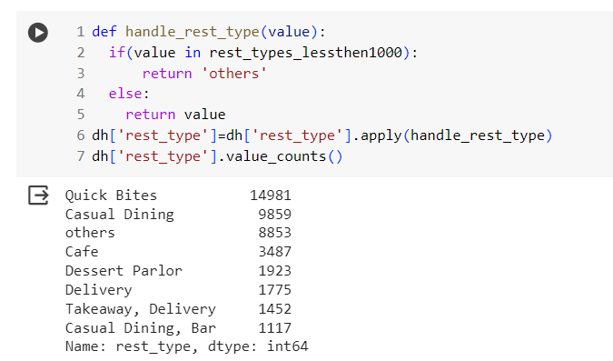

Step-9: Cleaning another column that is location

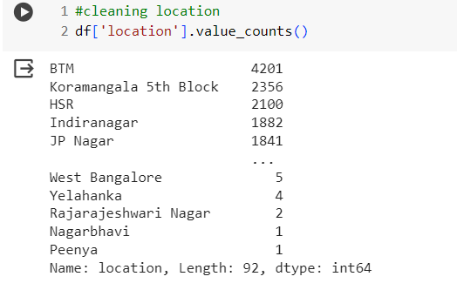

**Making clusters of values less than 300**

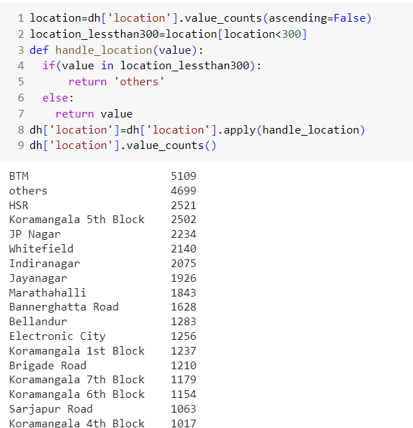

Step-10: Cleaning column named cuisines and making clusters of values less than 100

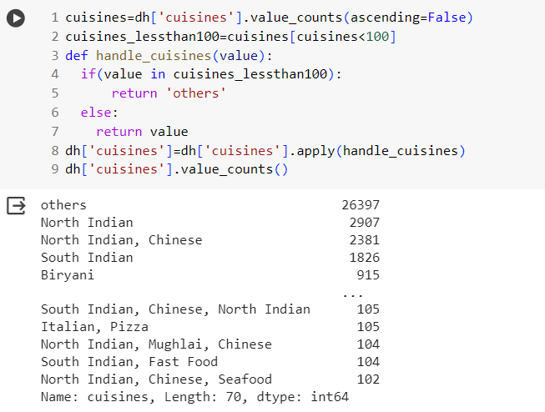

Step-11: Visualization of cleaned data

-- Count plot for various locations

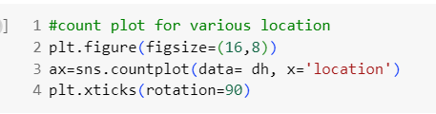

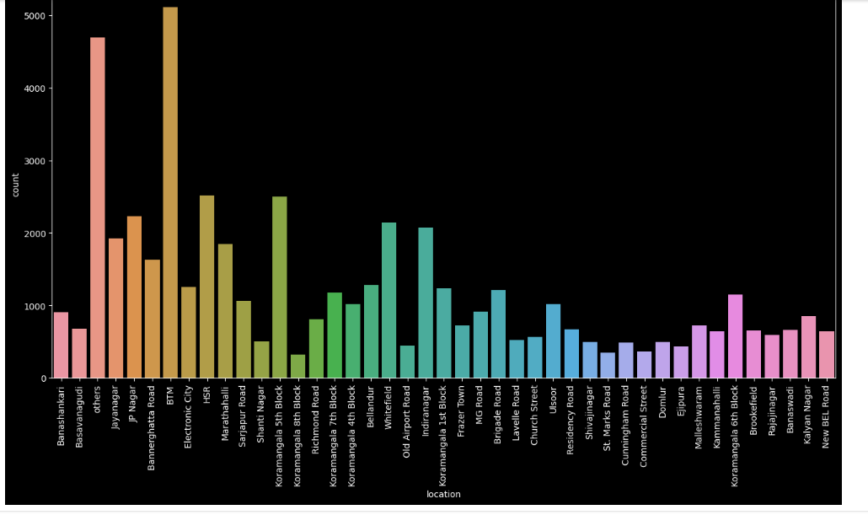

**From this count plot we can see maximum number of restaurants are present in “BTM” location.**

**So, if you want to open the restaurant you should not open in BTM as it already contains so many restaurants**.

-- Visualizing online order

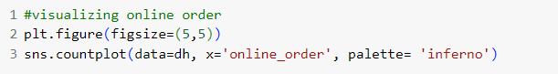

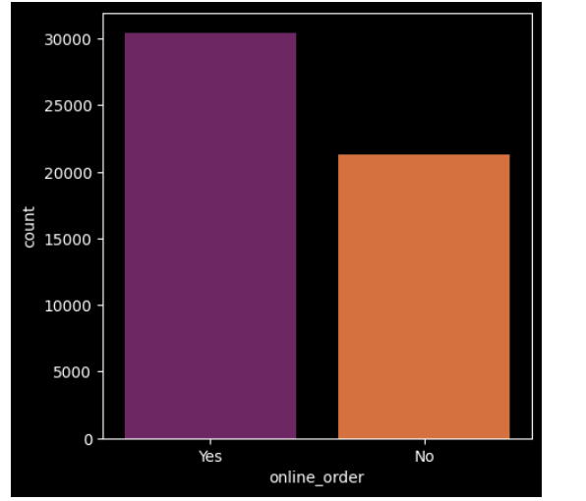

**From this we conclude that most of the restaurants is having online order facilities.**

--Visualizing Book Table

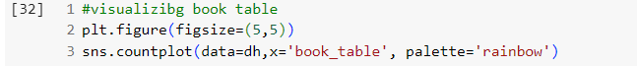

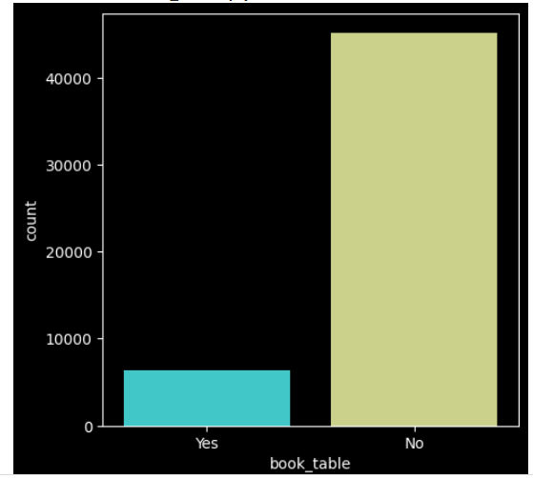

**As you can see that most tables don’t have booking table facilities.**

--Visualizing online order vs rate by using boxplot

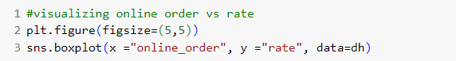

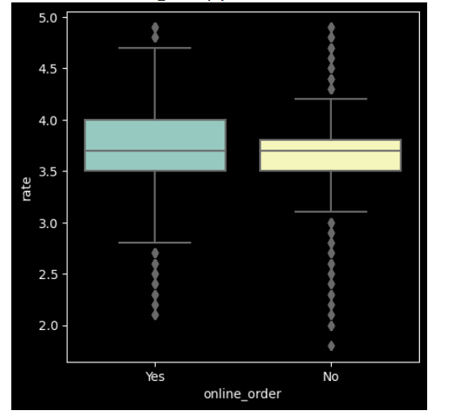

**From this it is clearly visible that restaurants having online facilities are highly rated when compared to the restaurants which don’t have those facilities.**

--Visualizing Book table vs rate by using boxplot

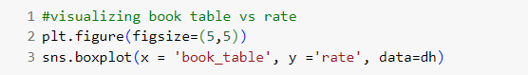

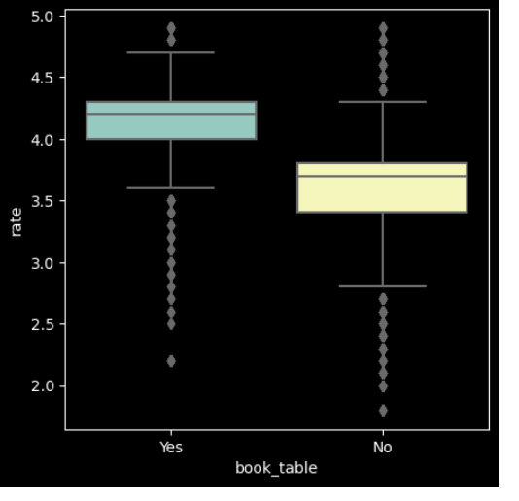

**From this it is clearly visible that restaurants having book table facilities have higher average rating.**

--Visualizing online order facility, location wise

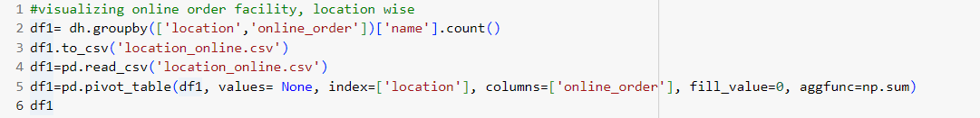

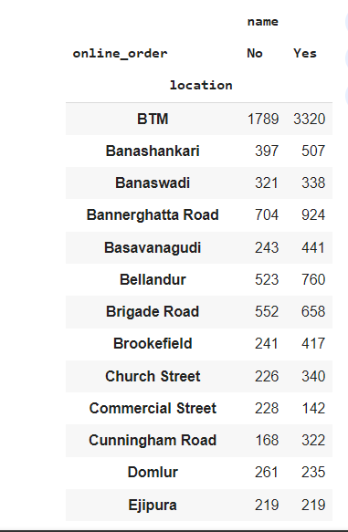



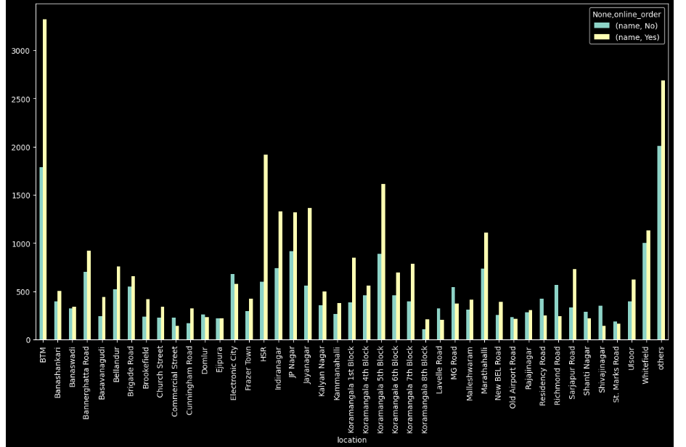

**So, we can say that location like BTM have 1789 restaurants which do not have facilities of online order and 3320 provides those facilities, by the graph we can observe that BTM have highest online order facilities with Lavelle Road have lowest online order facility so if you planning to open restaurants with online order Lavelle Road will be the best option.**

--Visualizing book table facility, location wise

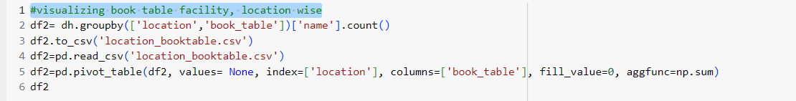

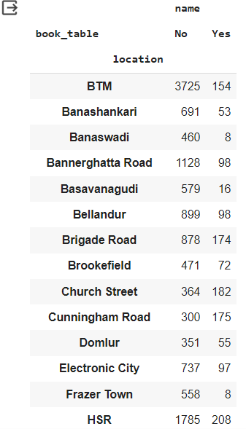



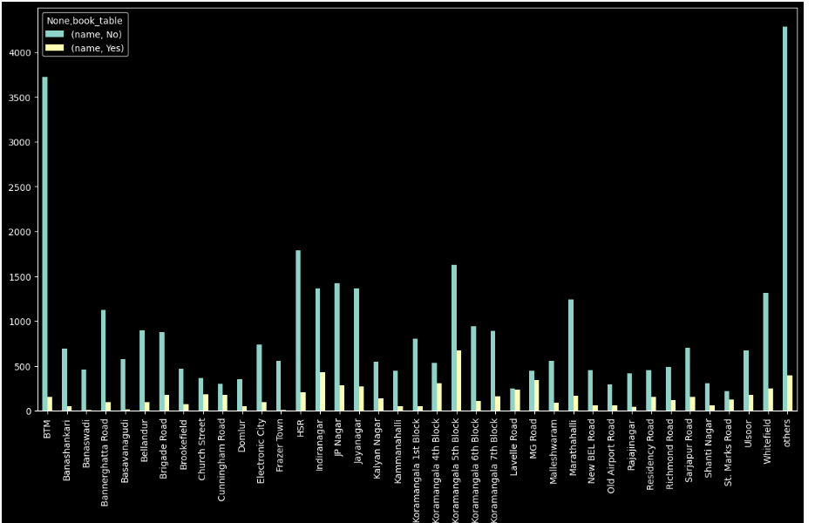

**From the above graph it is clearly visible that BTM have largest number of restaurants whoch don’t provide book table facilities but it will not be good option to open restaurant there as it already have some restrictions. So HSR will be the best option for opening the restaurants.**

--Visualizing types of restaurant vs Rate

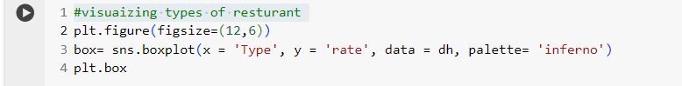

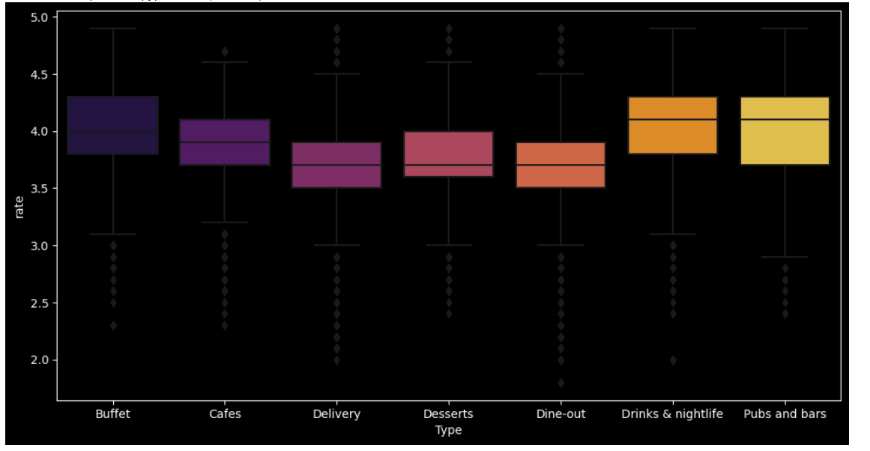

**From the above boxplot we can tell that maximum average rating is given to drinks and nightlife type of restaurants.**

--Grouping types of restaurant location wise

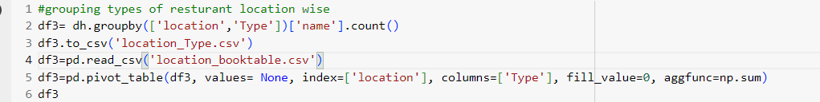

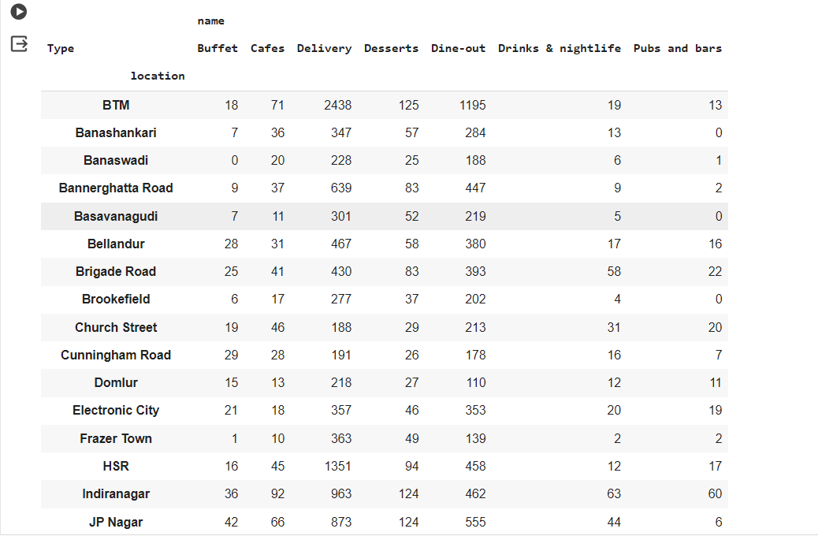



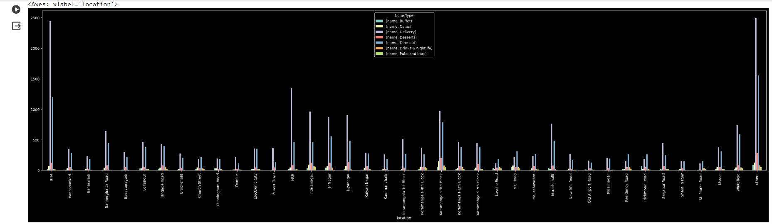

**From the above complicated graph, we can see that if you want to open pubs and bars you can open it in Shivaji Nagar or shanti Nagar.**

--No. of votes location wise

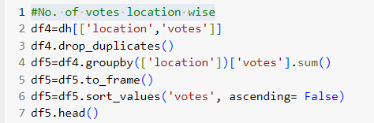

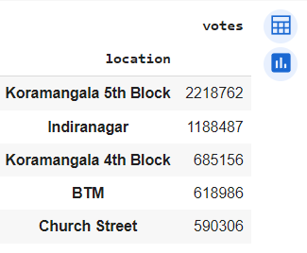

**Plotting bar graph for above table**

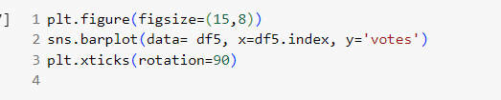

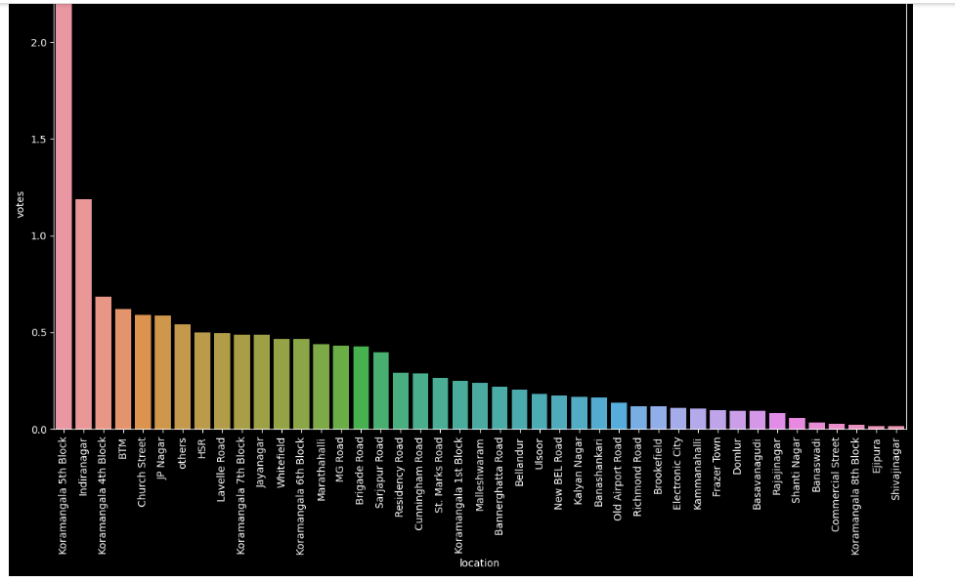

**From here we can see that Koramangala 5th Block have maximum number of voting, so if you open reataurant in this block than you will get a very good customer feedback.**

--Visualizing top cuisines

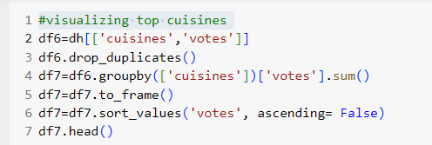

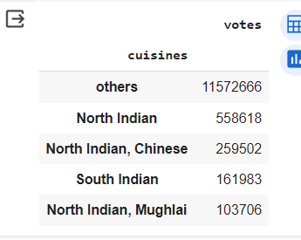

**By using iloc function we can remove others from the table.**

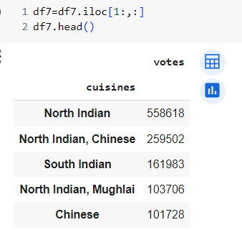

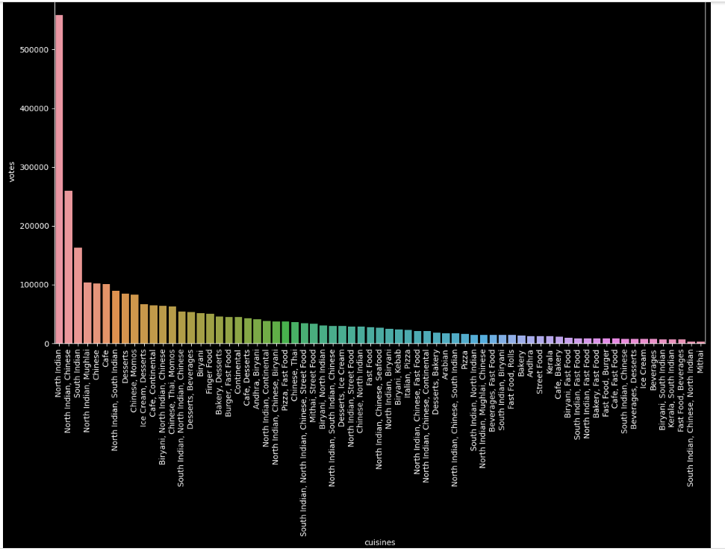

**North Indian has highest votes in cuisines followed by Chinese and South Indian, so if you thinking about opening any restaurant based on cuisine it must be north Indian.**

**In summary, our project not only sheds light on the current state of the Zomato ecosystem but also lays the groundwork for strategic decision-making by users, restaurant owners, and Zomato itself. This analysis contributes to a more informed and dynamic understanding of the restaurant industry, fostering a culture of continuous improvement and innovation.**